**SOFTWARE CONSTRUCTION 2**

**LAB 2 (Galadima Ahmed 2350499, Desmond Nduma 2350342)**

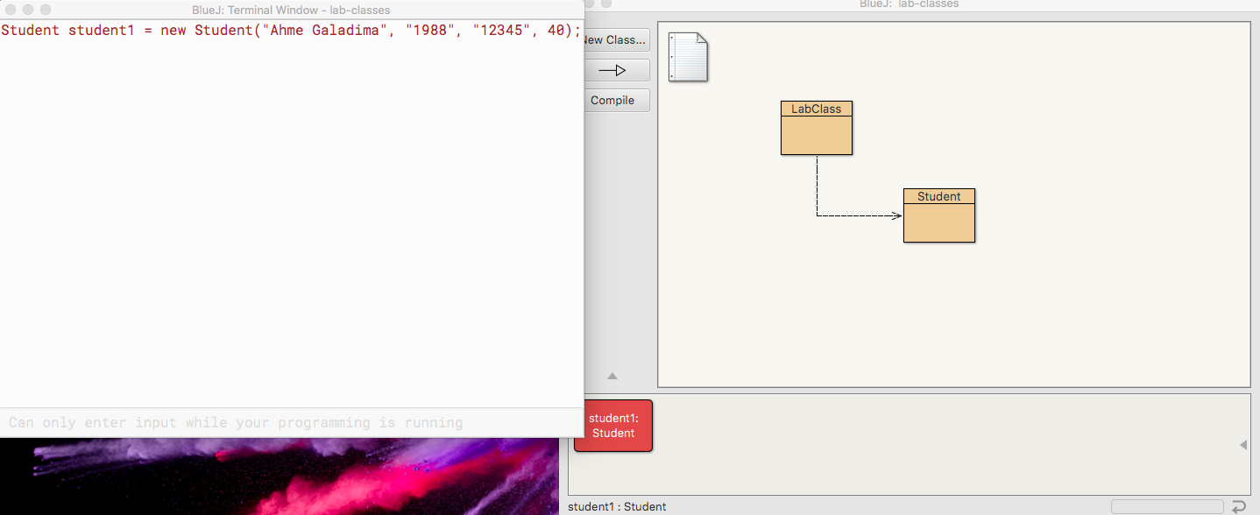**Preparations**

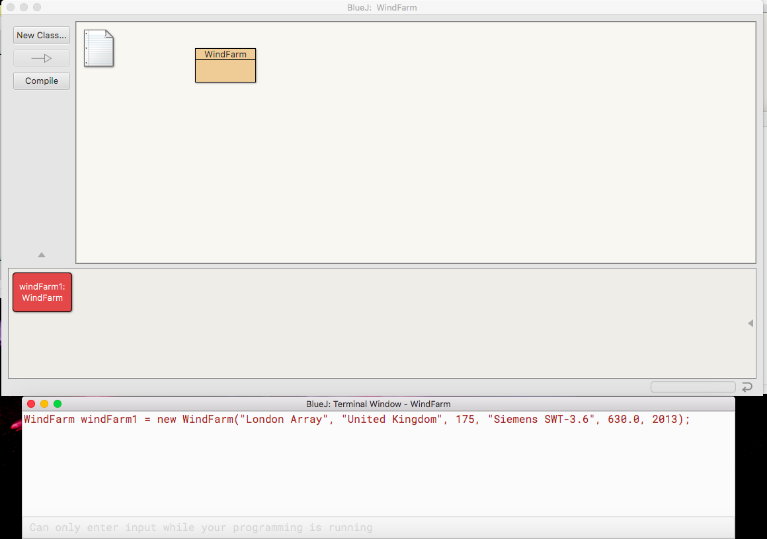 **Part A (wind farm 1)**

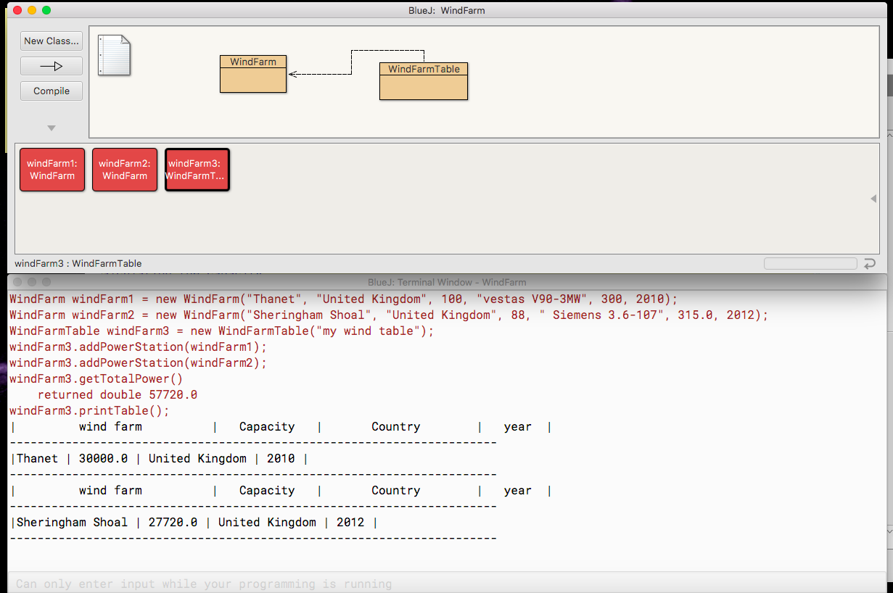**Part A(WindFarm 2)**

**Part B(PowerPlant 1)**

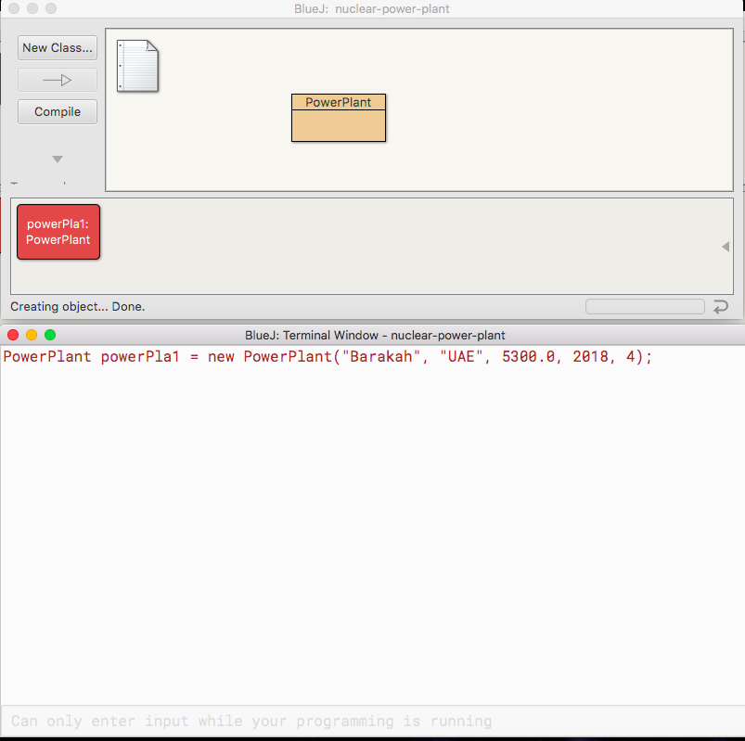

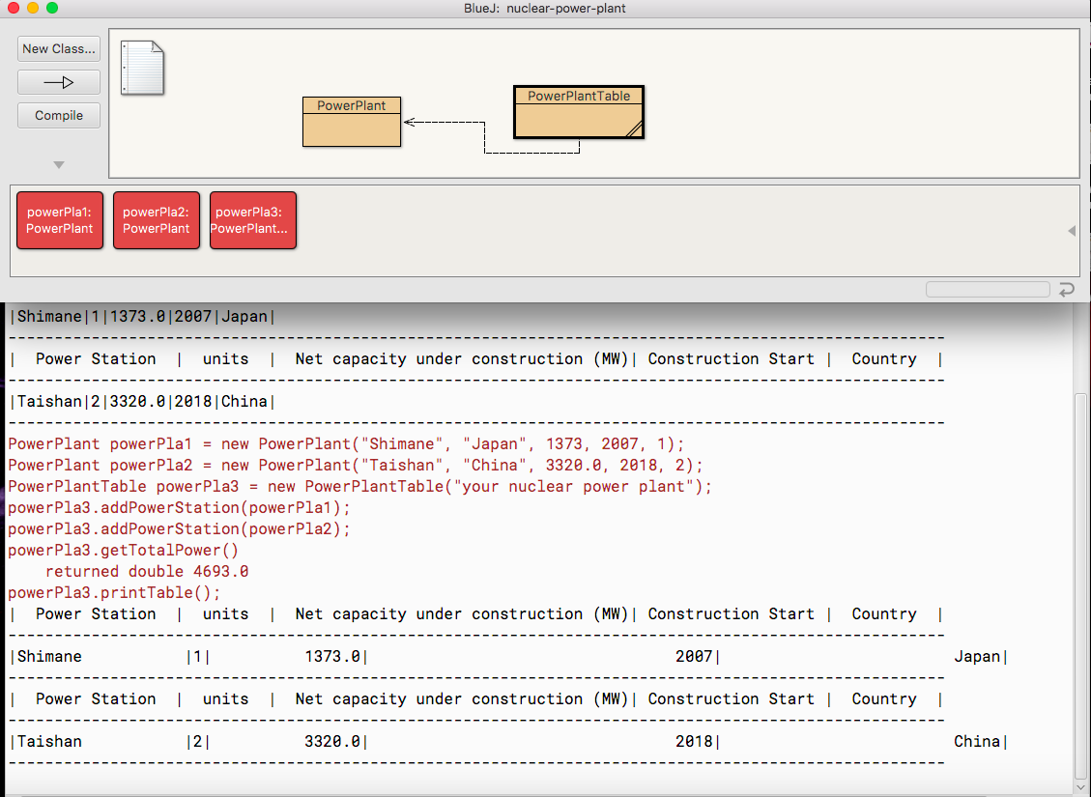**Part B (powerplant 2 Table)**